**Supporting Information**

**Section S1. The composition of model seawater brine**

Sodium chloride (NaCl), magnesium chloride hexahydrate (MgCl2·6H2O), calcium chloride dihydrate (CaCl2·2H2O), sodium sulfate (Na2SO4) and sodium bicarbonate (NaHCO3) were purchased from Sigma-Aldrich. The detailed composition of the SWB is provided in **Table S1**. The solution was prepared by dissolving the chemicals in Milli-Q DI water.

Table S1 The composition of model SWB in BMED system

|  |  |
| --- | --- |
| Chemicals | Concentration [g/L] |
| NaCl | 49.06 |
| MgCl2 | 10.4 |
| CaCl2 | 2.32 |
| Na2SO4 | 8.18 |
| NaHCO3 | 0.402 |

**Section S2. Stack resistance calculation**

The resistance of BMED stack can be defined as the sum of the resistance of individual part as shown in **Eq. 1**.

$$\begin{aligned}R_{stack}=\frac{N}{A}\left(R_{AEM}+R_{CEM}+R_{BPM}+\frac{d_{A}}{σ_{A}}+\frac{d_{B}}{σ_{B}}+\frac{d_{SWB}}{σ_{SWB}}\right)+R_{ele}\#\left(1\right)\end{aligned}$$

where $N$ is the number of repeating units, $A$ is the effective membrane area (m2), is the anion exchange membrane resistance (Ωm2), is the cation exchange membrane resistance (Ωm2), is the bipolar membrane resistance (Ωm2)., , were the thickness of AC, BC and SWBC (m), $σ_{AC}$, $σ_{BC}$ and $σ_{SWBC}$ is the conductivity of AC, BC and SWBC (S/m), and $R_{ele}$ is the electrode resistance (Ω).

The stack designed for testing $R_{ele}$ consisted of two electrode chambers, one serving as the anode compartment and the other as the cathode compartment, with a BPM positioned between them. The electrodes were titanium-coated with ruthenium. The setup was shown in **Fig. S1**.

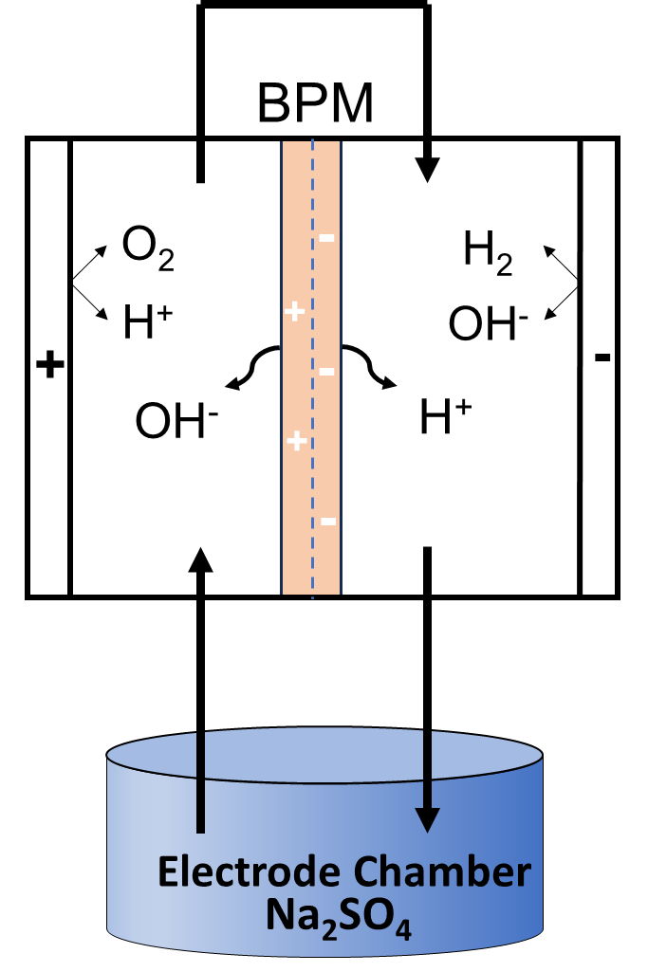

Figure S1 Schematic experimental setup for determining the electrode resistance. (Conditions: electrode solution = 0.3 M Na2SO4, current density = 5~20 mA/cm2)

For the measurement of electrode resistance in the BMED system, direct current is applied to the stack, and the corresponding voltage is monitored using the Power DC software. The current density was systematically varied from 5 to 20 mA/cm2, incrementing by 1 mA/cm2 at each step. At each current density, the system stabilized before the voltage was recorded to ensure accurate data**. Fig. S2** showed the voltage of the electrode chambers as a function of direct current. According to **Eq. 2**, $R_{ele}$ can be calculated according to Ohm’s Law. When the current density was 15 mA/cm2, Rele was 43.11 Ω.

$$\begin{aligned}R_{ele}=\frac{U_{ele}}{I_{ele}}\#\left(2\right)\end{aligned}$$

Where $U_{ele}$ and $I_{ele}$ is the voltage and current of electrode chamber.

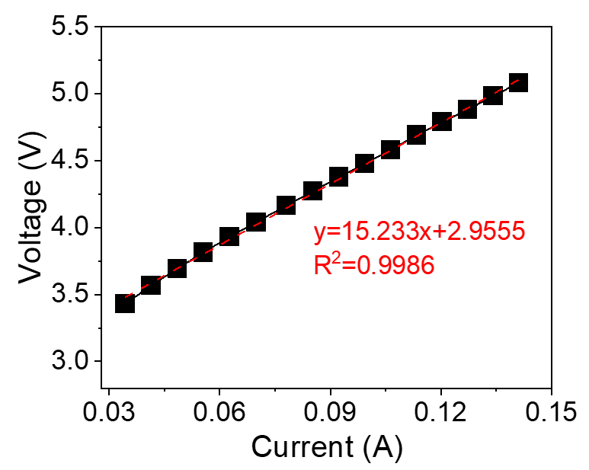

Figure S2 Voltage drop of the electrode compartments as a function of direct current.

The membrane resistance can be calculated by the conversion of Eq. (1):

$$\begin{aligned}R_{membrane}=\frac{N}{A}\left(R_{AEM}+R_{CEM}+R_{BPM}\right)=R_{stack}-R_{chamber}-R_{ele}\#\left(3\right)\end{aligned}$$

**Section S3. The quantification of scaling in BMED**

According to mass balance principles, the change in the number of moles of Ca²⁺ and Mg²⁺ in each solutions was equal to the amount of scaling. The mass of scaling of Ca and Mg can be calculated as follows:

$$\begin{aligned}m_{scaling-Ca}= C_{0,S}^{Ca}V_{0,S}-C_{t,S}^{Ca}V_{t,S}\#\left(4\right)\end{aligned}$$

$$\begin{aligned}m_{scaling-Mg}= C_{0,S}^{Mg}V_{0,S}-C_{t,S}^{Mg}V_{t,S}\#\left(5\right)\end{aligned}$$

Where $C_{0,S}^{Ca}$, $C_{0,S}^{Mg}$ and $C_{t,S}^{Ca}$, $C_{t,S}^{Mg}$ were the concentration of Ca2+ and Mg2+ (mg/L) at time 0 and $t$ in each chamber (i.e., AC, BC, SWBC and EC), repectively. $V_{0,S}$ and $V_{t,S}$ were the volume (L) of each chambers at time 0 and $t$. The concentration in EC was almost zero and can be ignored.

The reduction ratio of divalent ions can be calculated as follows:

$$\begin{aligned}R_{Ca}=\frac{C_{0,S}^{Ca}V_{0,S}-C_{t,S}^{Ca}V_{t,S}}{C_{0,S}^{Ca}V_{0,S}}\#\left(6\right)\end{aligned}$$

$$\begin{aligned}R_{Mg}=\frac{C_{0,S}^{Mg}V_{0,S}-C_{t,S}^{Mg}V_{t,S}}{C_{0,S}^{Mg}V_{0,S}}\#\left(7\right)\end{aligned}$$

**Section S4. BMED acid/base conductivity and SEC**

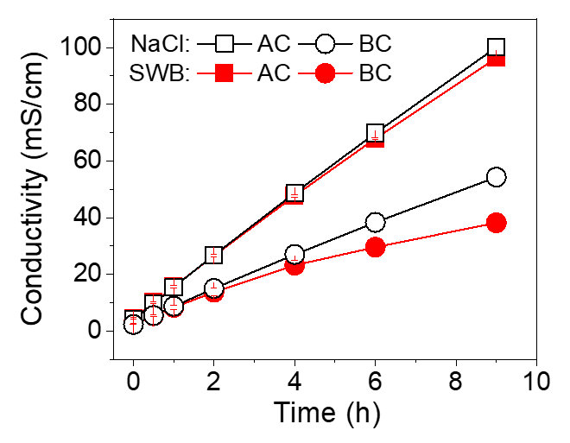

Figure S 3 The conductivity change of acid chamber and base chamber. (AC: acid chamber; BC: base chamber)

Energy consumption of produced acid and base (EC, kWh/kg) was calculated as follows:

$$\begin{aligned}{EC}^{i}=\frac{\int_{0}^{t}{U_{t}I_{t}dt}}{(C_{t}^{i}-C_{0}^{i})VM^{i}}\#\left(8\right)\end{aligned}$$

Where $U_{t}$ is the voltage (V) and $I_{t}$ is the current (A) at time $t$. $C_{t}^{i}$ and $C_{0}^{i}$ were the concentration of solution $i$ (i.e., base or acid) at time $t$ and 0 (mol/L) $V$ is the volume of circulated volume of acid or base solution (L). $M^{i}$ is the molar weight of base or acid (g/mol).

When BMED treating SWB, scaling increased the resistance of the stack (**Fig. 2 c**). Under the constant current, the voltage across the BMED system remained elevated throughout the experiment (**Fig. 2b**). Since EC was proportional to the voltage (**Eq. 8**), it naturally led to higher EC compared to NaCl.

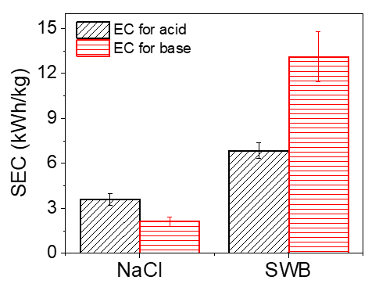

Figure S 4 The energy consumption of the entire process to produce acid and base.

Section S5. The recycling test of BMED

In order to understand whether the performance of scaled membrane would decrease after removing scaling, a recycling test was performed. The system performance (voltage, conductivity, pH of SWBC and concentration of generated acid/base) was compared with the stack with pristine membranes and unscaled membranes.

After tests in SWB, the stack was cleaned with DI water for 10 minutes. The stack was disassembled, and the membrane was taken out for flushing. The scaling on the membrane was rinsed with DI water. Then the membranes (named as scaled membrane) were reassembled in the stack. The cleaning of stack with DI water was repeated several times until the conductivity of the flushing water was below 5 μS/cm. The stack was used to run the test with NaCl to measure the performance of BMED system with scaled membranes.

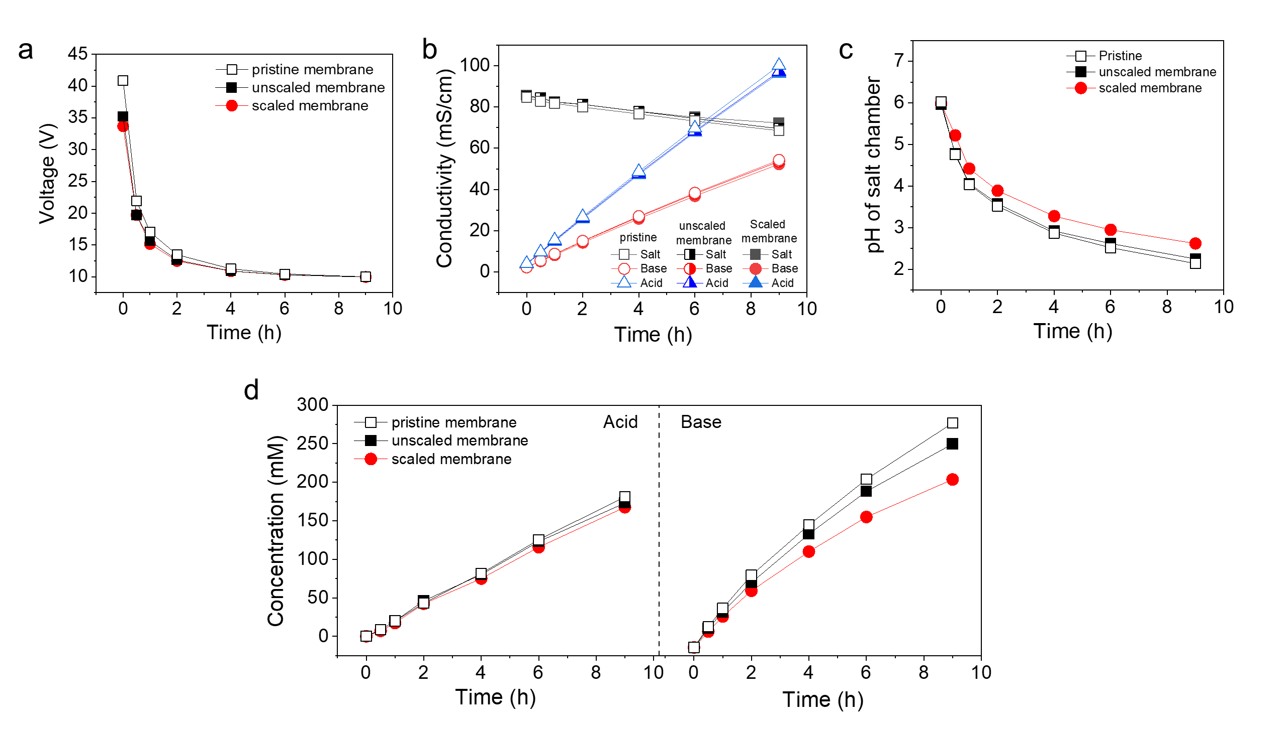

Figure S 5 Performance change before scaling, after scaling and after cleaning.

Section S6 Scaling formation in chambers

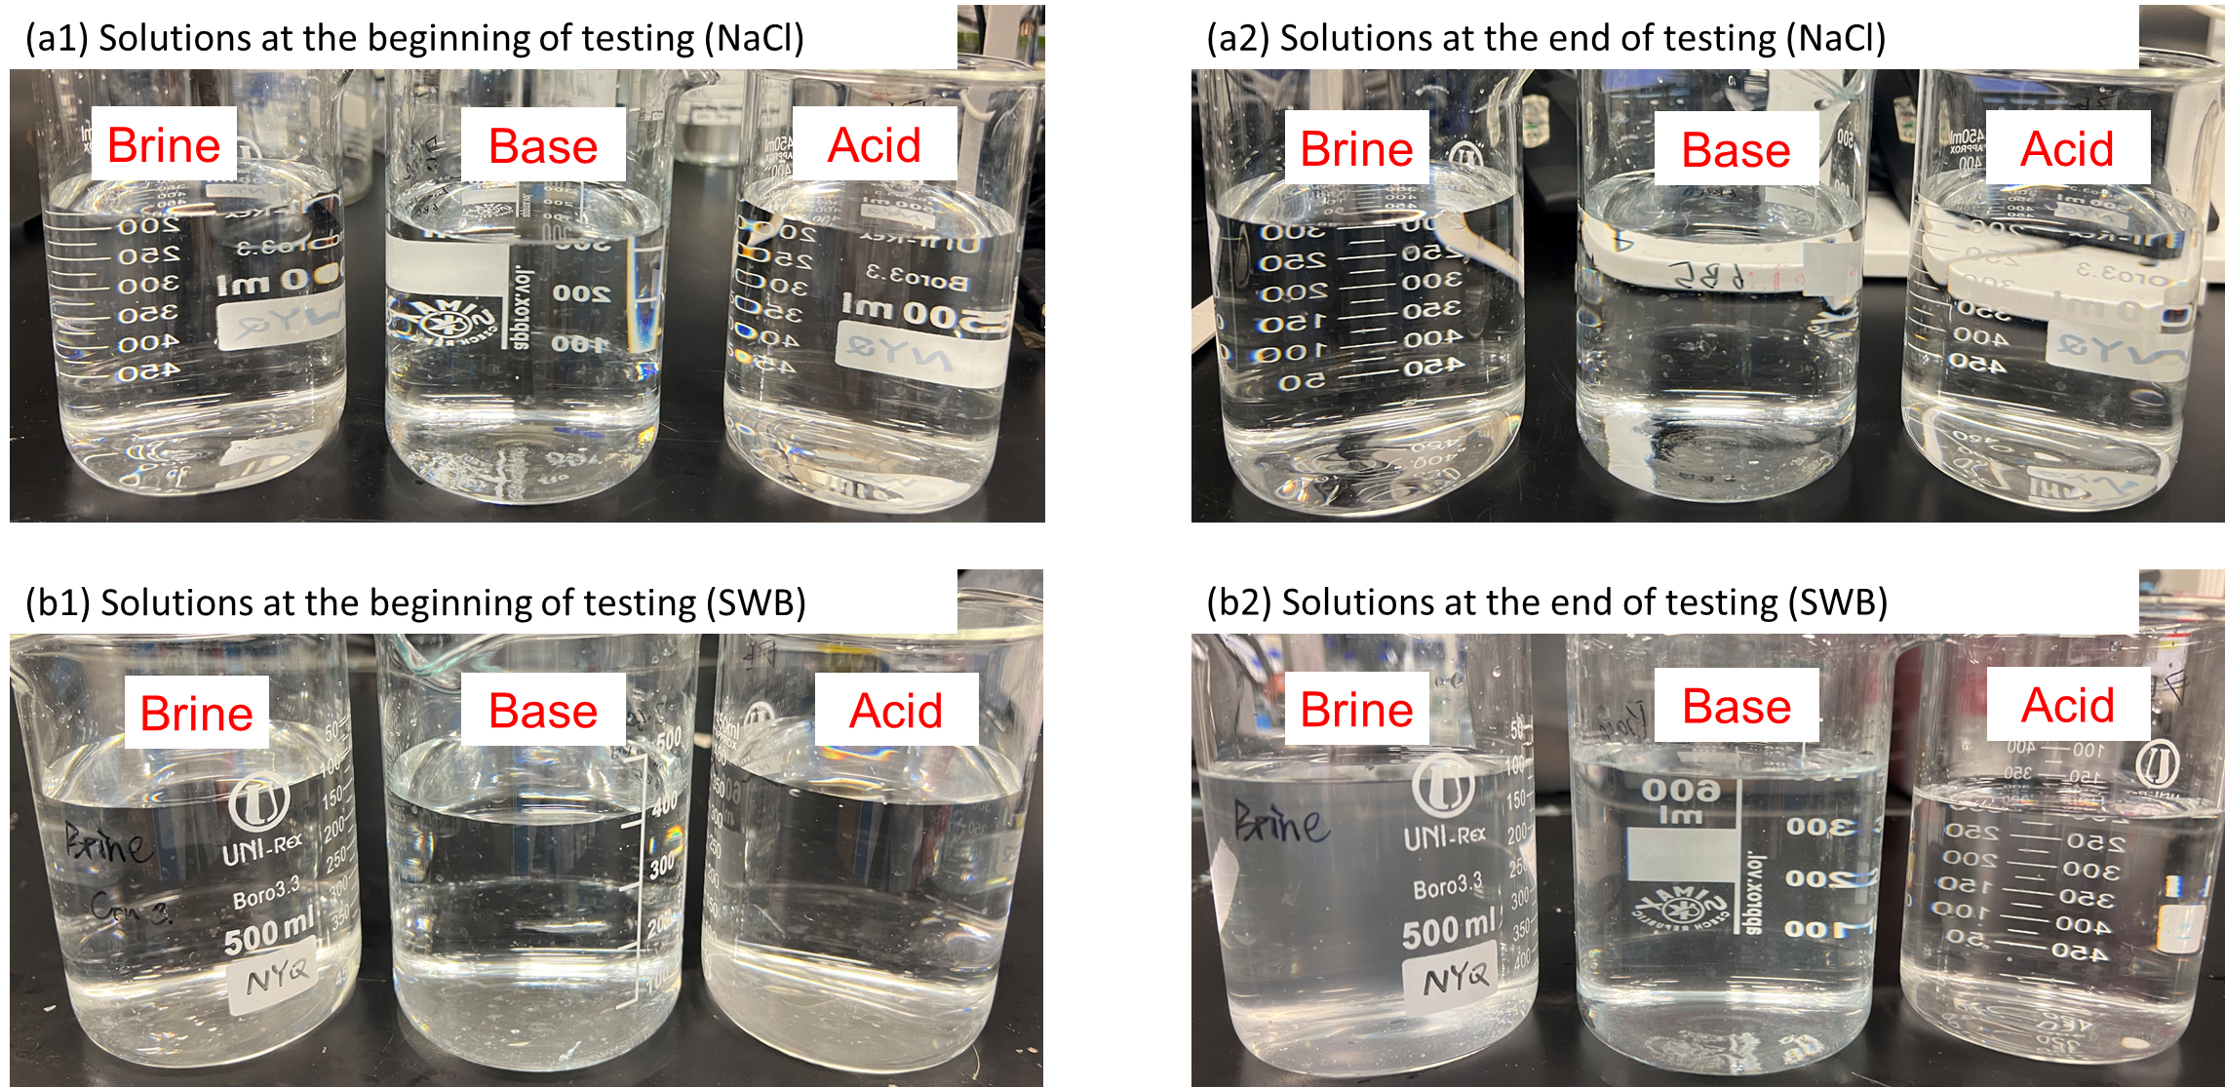

Figure S 6 Photos of solution at the (a1) beginning and end (a2) of BMED treating NaCl. Photos of solution at the (a1) beginning and end (a2) of BMED treating SWB.

Table S2 The turbidity [NTU] of solution in SWB and base chamber

|  |  |  |  |  |
| --- | --- | --- | --- | --- |
|  | BMED treating NaCl | | BMED treating SWB | |
|  | Base chamber | SWB chamber | Base chamber | SWB chamber |
| Initial | 0.11±0.01 | 0.23±0.01 | 0.11±0.01 | 0.14±0.02 |
| Final | 0.20±0.04 | 0.38±0.03 | 29.40±0.92 | 45.23±0.12 |

Section S6. Characterization of pristine IEMs and IEMs after NaCl tests

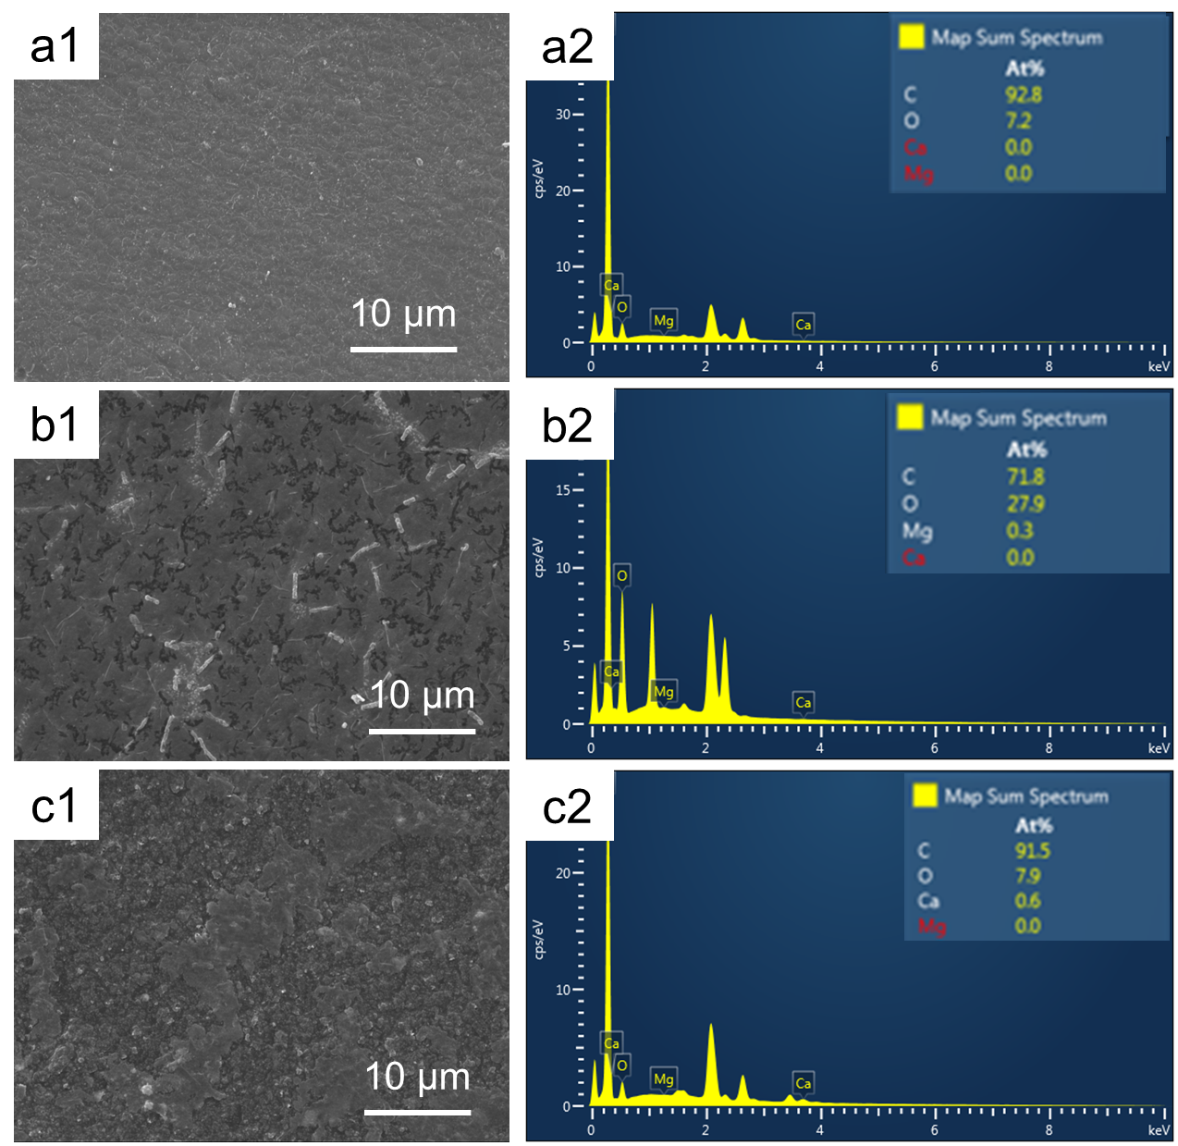

Figure S 7 Characterization of pristine IEMs. AEM: (a1) SEM image; (a2) EDS map spectrum. CEM: (b1) SEM image; (b2) EDS map spectrum. BPM (AEL): (c1) SEM image; (c2) EDS map spectrum

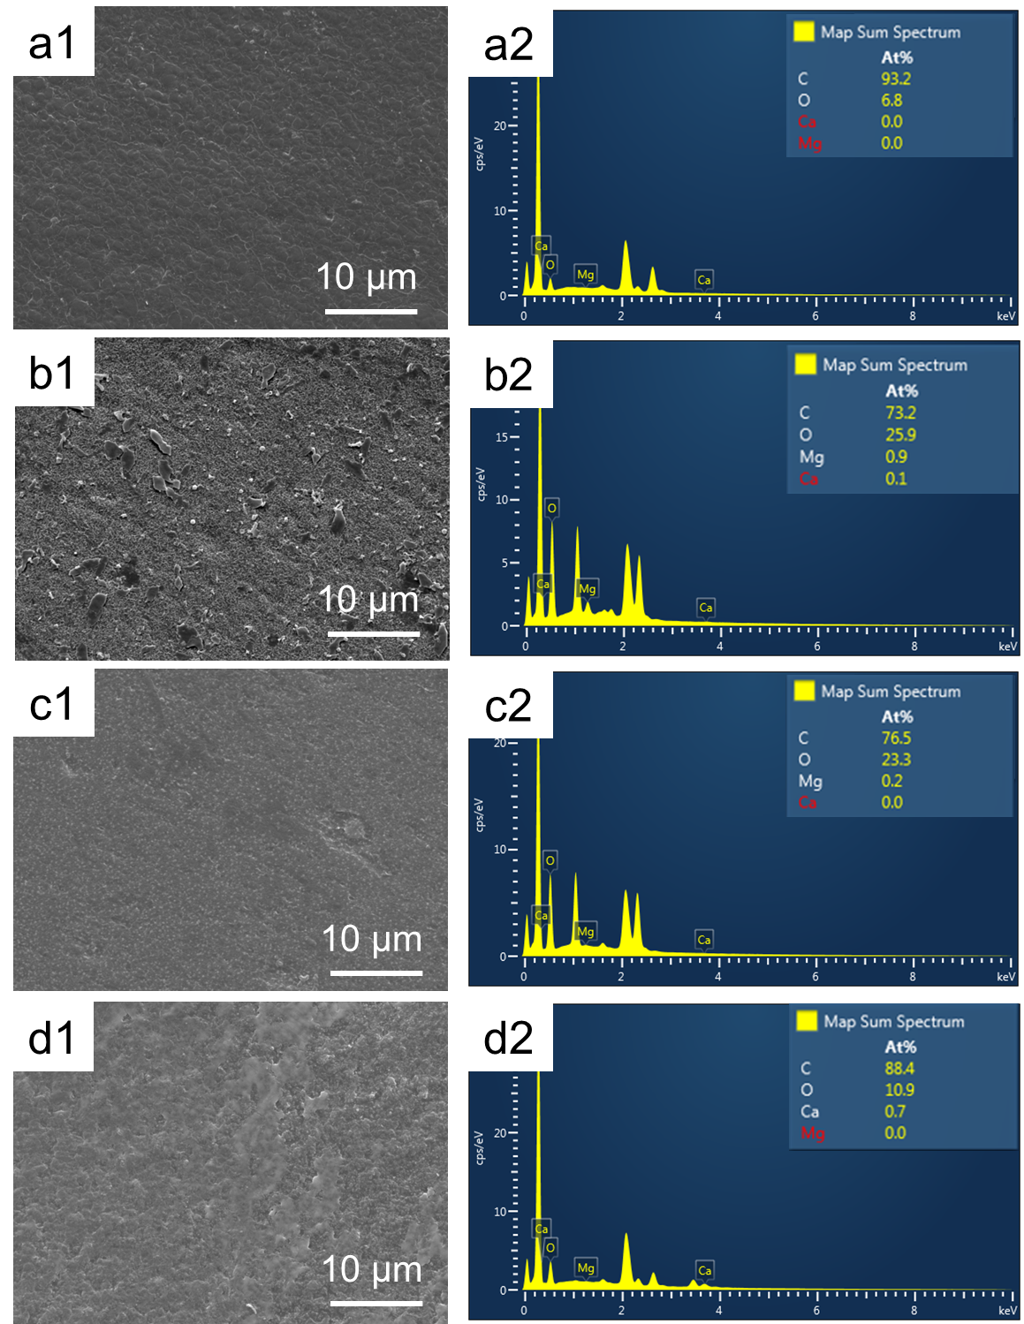

Figure S 8 Characterization of IEMs after BMED tests treating NaCl. AEM facing SWBC: (a1) SEM image; (a2) EDS map spectrum. CEM facing SWBC: (b1) SEM image; (b2) EDS map spectrum. CEM facing BC: (c1) SEM image; (c2) EDS map spectrum. BPM facing BC: (d1) SEM image

Section S7. The composition of scaling on IEMs

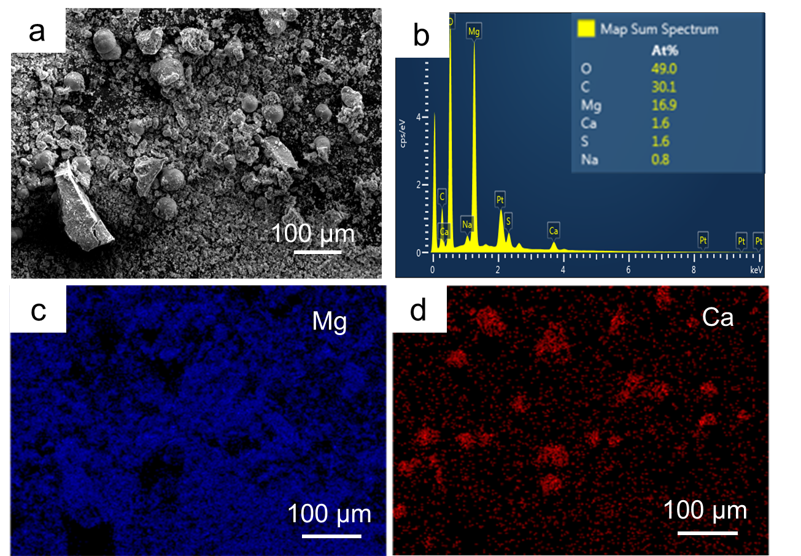

Figure S 9 The morphology of deposits on CEM facing SWBC (a) SEM image; (b) EDS map spectrum; EDS elemental mapping image of (c) Mg and (d) Ca

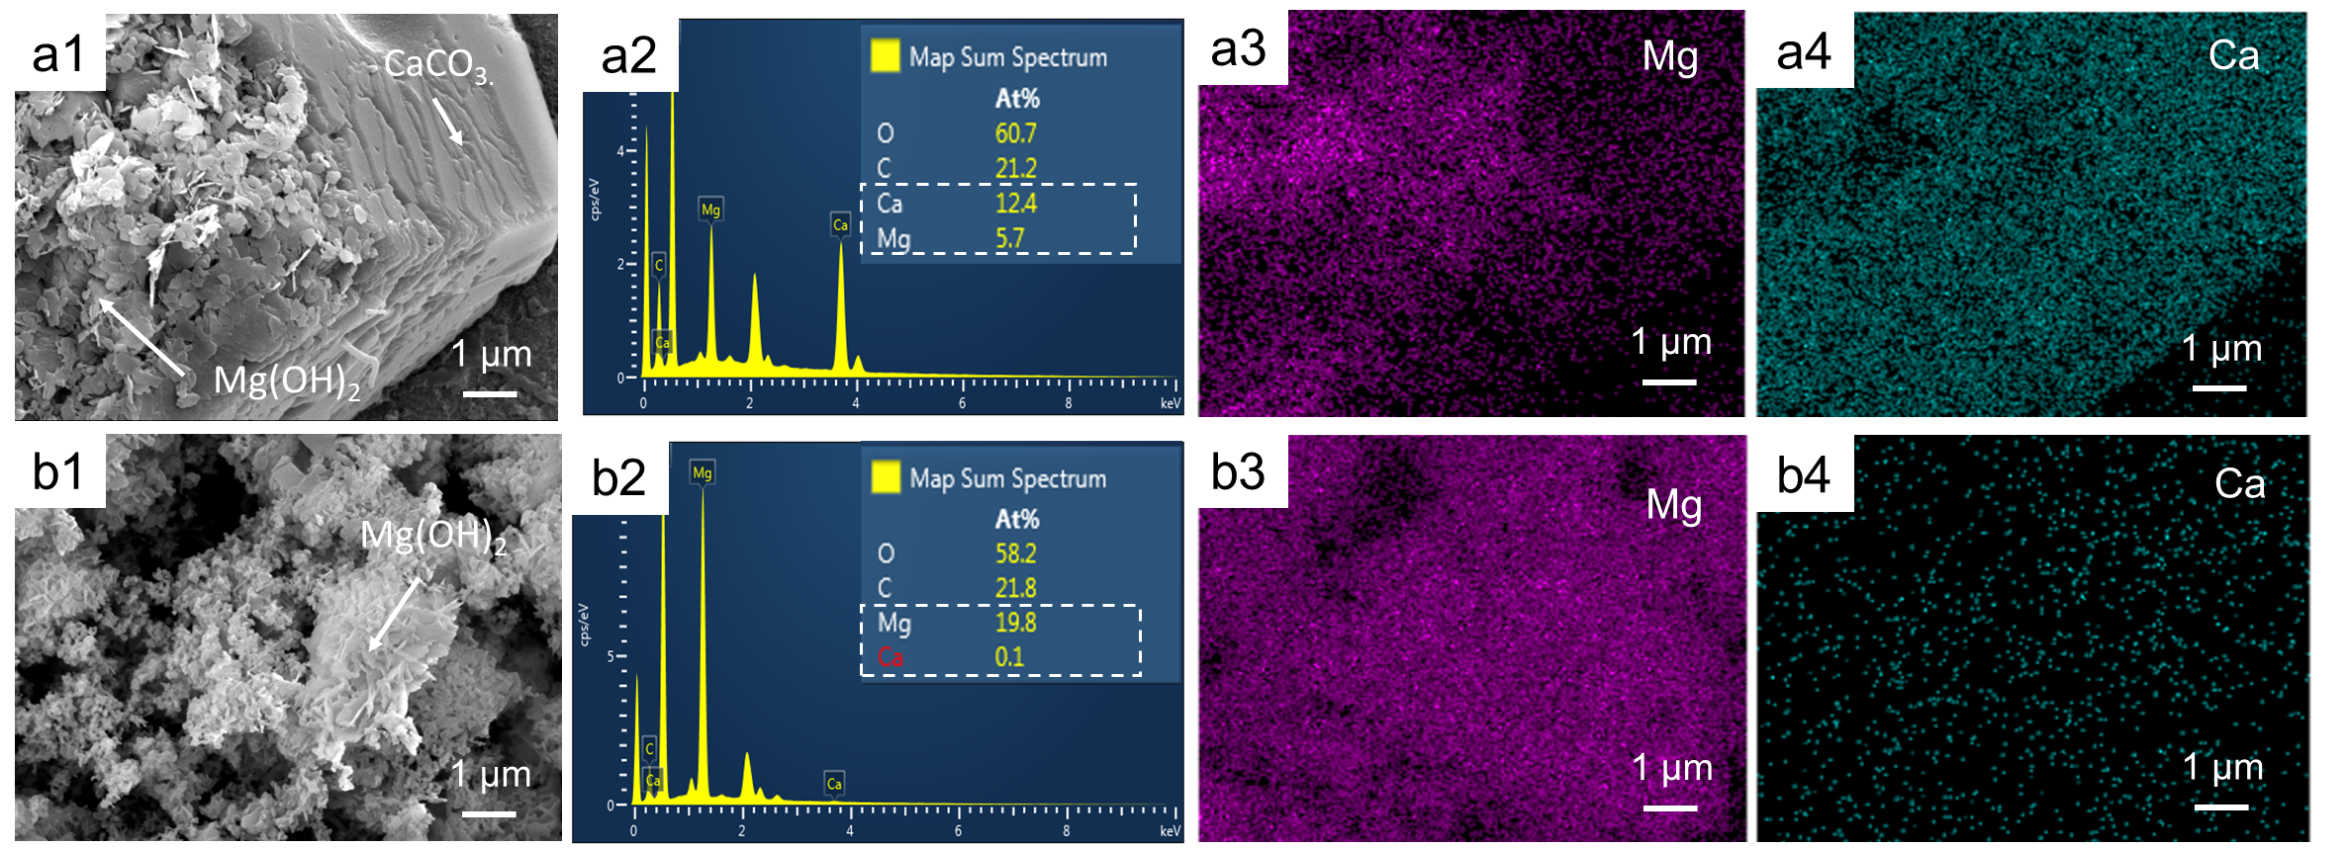

Figure S 10 The morphology of deposits on CEM facing BC: (a1)(b1) SEM images; (a2)(b2) EDS map spectrum; EDS elemental mapping image of (a3)(b3) Mg and (a4)(b4) Ca.

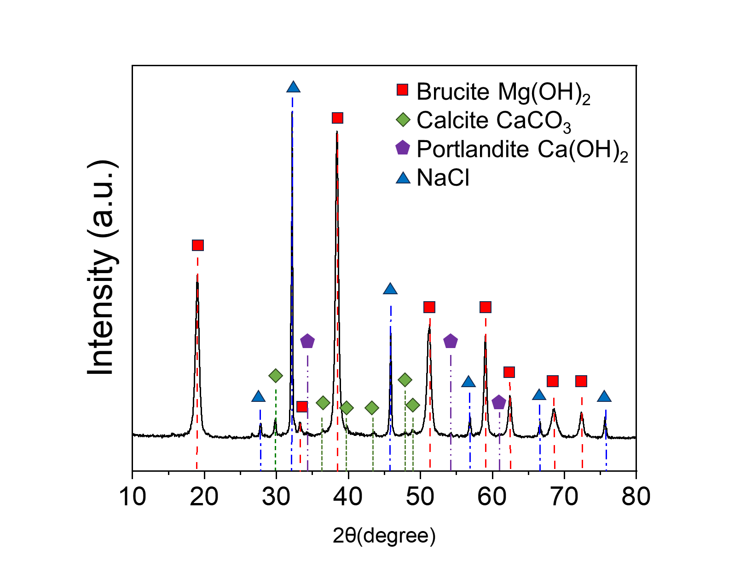

Figure S 11 X-ray diffraction spectra for the precipitates collected in the stack.

Section S8. The concentration change in acid chamber

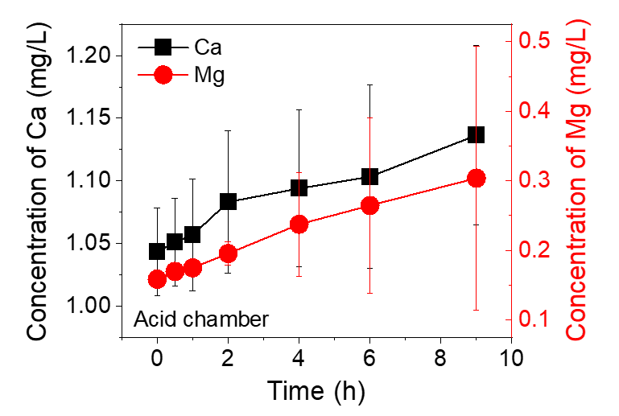

Figure S 12 The concentration change of Mg2+ and Ca2+ in the acid chamber.

Section S9. The calculation of transport number

To evaluate the transport number and assess OH- leakage through the membrane, a two-compartment electrochemical cell was assembled as shown in Fig. S13. The setup consists of two chambers separated by an ion-exchange membrane, with each compartment equipped with an electrode connected to a voltmeter for potential measurement. The left compartment was filled with 0.2 M NaOH, while the right compartment contained 0.1 M NaOH. The concentration gradient drives ion transport across the membrane. By monitoring the voltage difference between the two solutions over time and analyzing the resulting electrochemical potential, the counter-ion transport number can be determined (Eq. 12). As the sum of transport number of counter-ion and co-ion is 1 (Eq. 10), transport number of counter-ion can also reflect the leakage of co-ion.

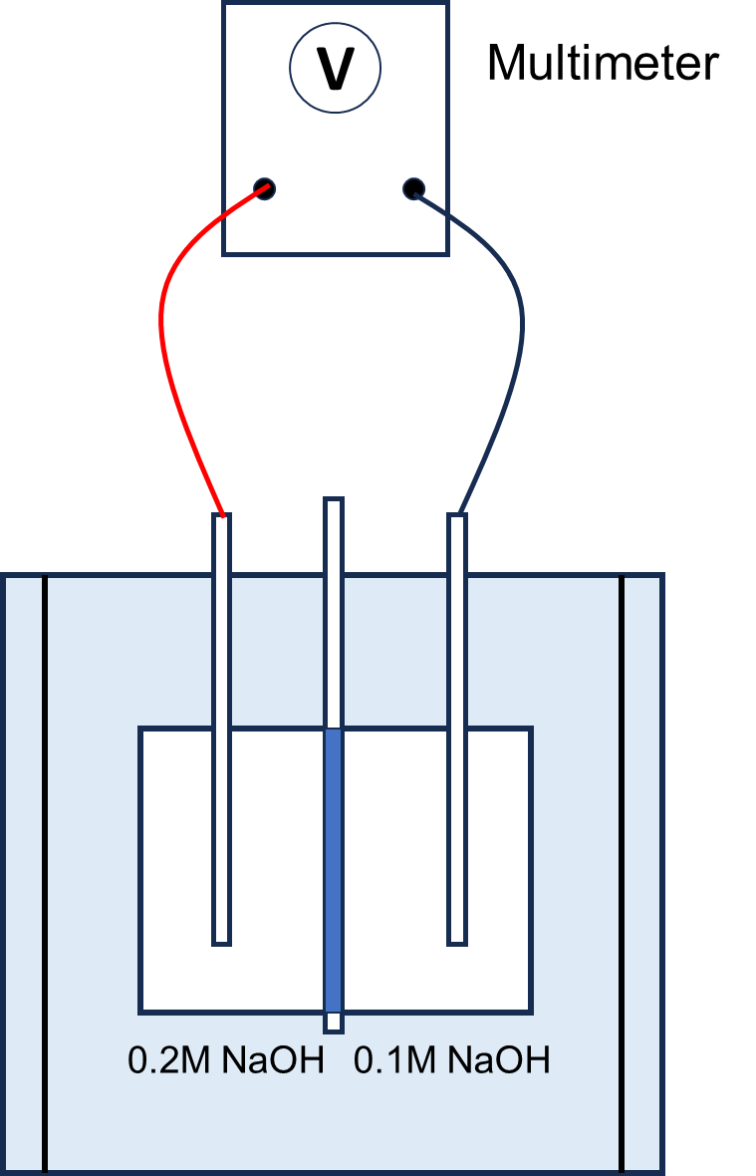

Figure S 13 The schematic diagram of a two-cell mode measurement module for transport number

The membrane potential is evaluated by the Nernst equation Eq. 9:

$$\begin{aligned}E_{m}=\left(\overline{t_{+}}-\overline{t_{-}}\right)\frac{RT}{zF}\ln\left(\frac{a1}{a2}\right)\#\left(9\right)\end{aligned}$$

Where Em is the membrane potential (mV); $\overline{t_{+}}$ and $\overline{t_{-}}$ is the cations and anions transport numbers of the membrane, respectively; $a1$ and $a2$ is the activity of the of electrolytic solutions; z is the valence of the electrolyte; F is the Faraday constant.

In this research, the electrolyte is NaOH, so z =1. Meanwhile,

$$\begin{aligned}\overline{t_{+}}+\overline{t_{-}}=1\#\left(10\right)\end{aligned}$$

So Eq. 9 can be written as:

$$\begin{aligned}E_{m}=\left(2\overline{t_{+}}-1\right)\frac{RT}{F}\ln\left(\frac{a1}{a2}\right)\#\left(11\right)\end{aligned}$$

In that case, the transport number of counter-ion:

$$\begin{aligned}\overline{t_{+}}=\frac{E_{m}F}{RTln\left(\frac{a1}{a2}\right)}\#\left(12\right)\end{aligned}$$

The transport numbers of different IEMs are shown in Fig. S14.

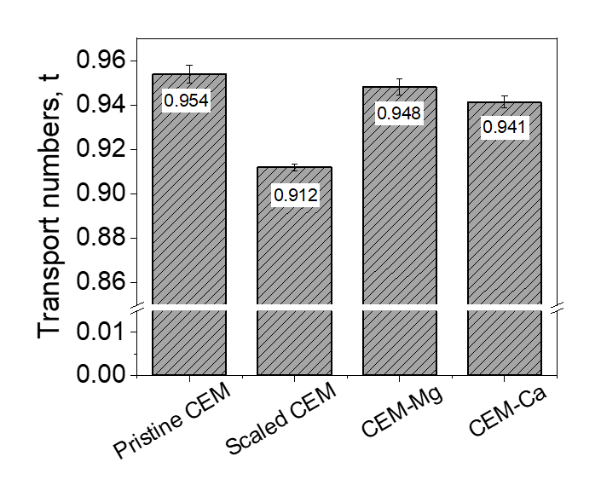

Figure S 14 The transport number of different CEMs

Section S10 The cross-section of scaled CEM and BPM(AEL side)

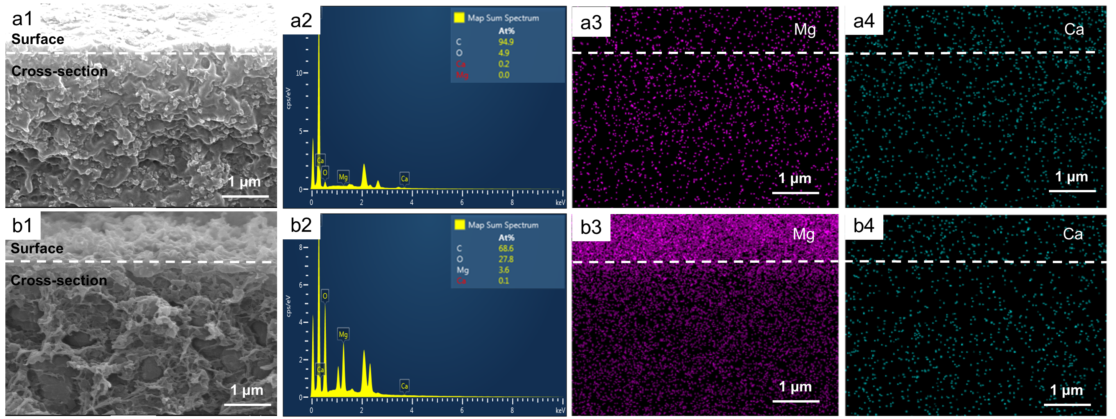

Figure S 15 The SEM graph and EDS map spectrum of cross-section of membranes (White line is the dividing line of cross-section and membrane surface). Cross-section of CEM after tests: (a1) SEM diagram; (a2) EDS map spectrum; EDS elemental mapping image of (a3) Md and (a4) Ca. Cross-section of BPM(AEL) after tests: (b1) SEM diagram; (b2) EDS map spectrum; EDS elemental mapping image of (b3) Mg and (b4) Ca.